

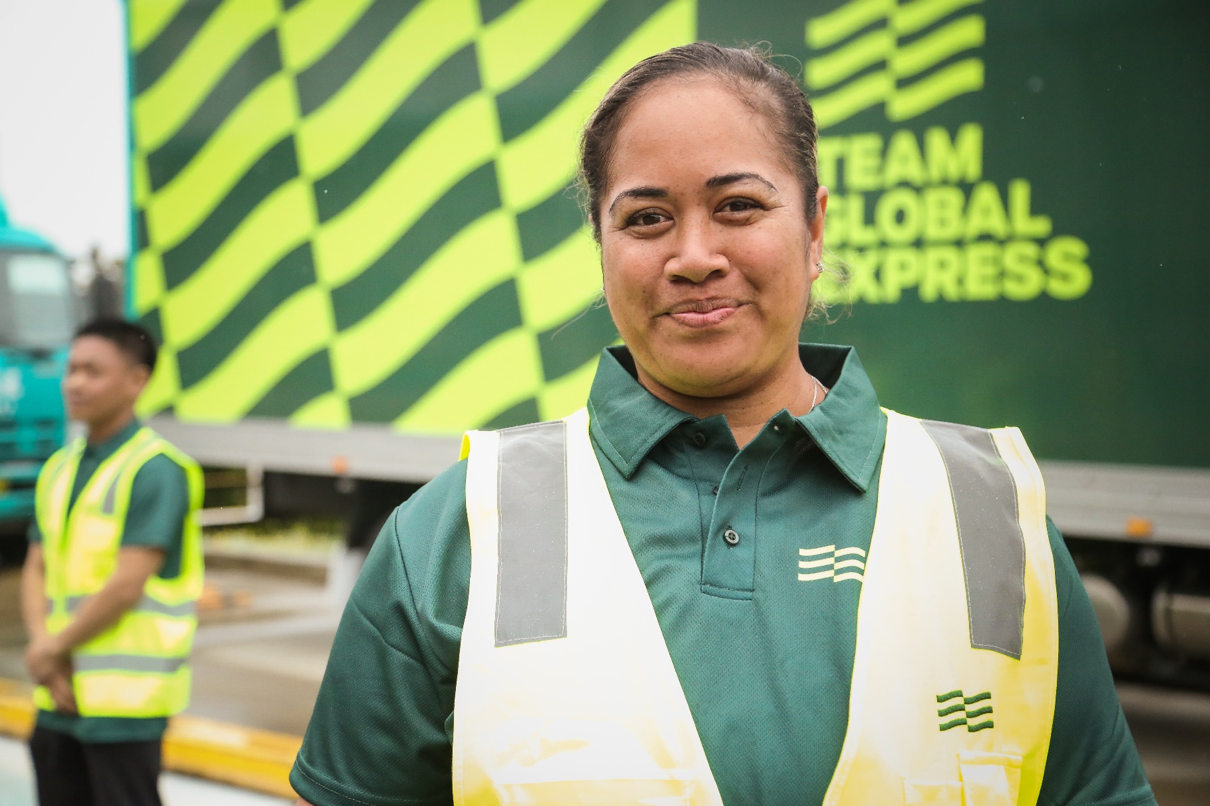

Presented to: Customer Name

Presented by: Your Name

Date: Date

“Strictly Confidential”

Name
Position

Company Name
Address 1
Address 2

26 July 2024

SUBJECT: Proposal of Intermodal & Specialised Rates & Services

Team Global Express is pleased to have the opportunity to provide our proposed response for the provision of Intermodal & Specialised Services.

Should you have any questions throughout your evaluation process, please do not hesitate to contact me.

We look forward to your further advice.

Yours faithfully,

Name
Position
Team Global Express

Pricing

Origin | Destination | Mode | Equipment Type / Config | Base Weight (Tonnes) | Base Price  (up to Base Weight) | Incremental Rate  (per unit above base) | Fuel Surcharge | Transit Days

Ancillary and Other Charges – (Prices exclude GST)
Charge | Description | Charged Method | Amount
Account Service Fee | Charged to all invoice / statements | Per invoice | $33.65
Manual Consignment Fee | Charged when a customer chooses to use a paper consignment note rather than creating a shipment on MyTGE  Freight that moves through our Tasmanian network | Per manual consignment | $26.00  $35.00
Fuel Surcharge | Variable monthly fuel surcharge subject to change | Per consignment | Reviewed monthly
Road Toll Surcharge | Where a consignment travels ex Melbourne and/or into Melbourne | Per consignment | 0.43%
Rail Cancellation Fee | Fee charged if cancelled less than 24 hours from departure (Rail cut-off time) | Per event | $367.33
Futile Pickup / Delivery Fee | Customer freight not available for pickup or delivery at customer site when vehicle has been requested to pickup/deliver by the customer | Per event | $262.40
Dangerous Goods Surcharge All Interstate Corridors | For the additional labour, facility and legislative compliance costs involved with processing and moving goods classed as ‘Dangerous’ under the Australian Dangerous Goods Code | Per container | $383.10
Dangerous Goods Surcharge North Queensland | Fee applicable between Brisbane and North Queensland corridor to and from. Additional Fee for Interstate to/from North Queensland, additional fee to the above per container fee. | Per container | $205.00
Demurrage @ Wharf/Customer | Charged per hour after included time (60 mins) | Per hour | $131.20
Wharf Cartage Fees | Coastal linehaul rates are inclusive of Coastal fees and surcharges at the time of quoting as charged by wharf operators and coastal linehaul providers. Please note these fees are subject to change without notice by the depots/terminals. Team Global Express will monitor any such changes and will advise of any increases where required. | Per TEU | Per Table 3
Coastal Container Maintenance Charge | ANL introducing a container maintenance charge set to avoid all container damage claims up to $250. The charge will be effective from Tuesday 1 March 2022 on all coastal import legs | Per TEU | $22.05
Container Storage | Rates include 2 days of on-site storage at destination (Not including day of arrival). Storage days over and above this will be charged via daily storage rate | Per container, Per day | $21.00
Via Depot (Rail Drag) | This charge is triggered when customers are unable to accept rail deliveries within the free storage period of 2 days (Not including day of arrival) | Per event | $125.00
Tasmania Service - Australian Quarantine & Inspection Service (AQIS) | Quarantine checks for all freight Inbound to Tasmania - subject to change as determined by AQIS | Per consignment | $43.95 per unit (includes 20’, 28’ and 40’ FCL) or $1.45 per cubic metre for LCL consignments or $1.00 minimum charge per consignment

table 3: coastal fees and surcharges (included in coastal rates)

EXPORT | MELBOURNE |  | SYDNEY |  | PERTH |  | ADELAIDE |  | BRISBANE
 | 20’ | 40’ | 20’ | 40’ | 20’ | 40’ | 20’ | 40’ | 20’ | 40’
Vehicle Booking System (VBS) Fees | $52.70 | $52.70 | $48.70 | $48.70 | $58.40 | $58.40 | $30.50 | $30.50 | $51.00 | $51.00
Container Chain Fees | $68.00 | $68.00 | $68.00 | $68.00 | $62.60 | $62.60 | $60.00 | $60.00 | $108.00 | $108.00
Energy Charge | $6.04 | $6.04 | $6.04 | $6.04 | $3.50 | $3.50 | $6.04 | $6.04 | $6.04 | $6.04
Chain of Responsibility | $14.80 | $14.80 | $14.80 | $14.80 | $14.80 | $14.80 | $14.80 | $14.80 | $14.80 | $14.80
Terminal Access Charges / Infrastructure Fee | $175.70 | $175.70 | $173.03 | $173.03 | $50.00 | $50.00 | $112.50 | $112.50 | $193.00 | $193.00
Bunker Fuel Environmental Levy | $163.00 | $326.00 | $163.00 | $326.00 | $163.00 | $326.00 | $163.00 | $326.00 | $163.00 | $326.00

IMPORT | MELBOURNE |  | SYDNEY |  | PERTH |  | ADELAIDE |  | BRISBANE
 | 20’ | 40’ | 20’ | 40’ | 20’ | 40’ | 20’ | 40’ | 20’ | 40’
Vehicle Booking System (VBS) Fees | $48.70 | $48.70 | $48.70 | $48.70 | $58.40 | $58.40 | $30.50 | $30.50 | $51.00 | $51.00
Container Chain Fees | $68.00 | $68.00 | $68.00 | $68.00 | $62.60 | $62.60 | $60.00 | $60.00 | $108.00 | $108.00
Energy Fee | $6.04 | $6.04 | $6.04 | $6.04 | $3.50 | $3.50 | $6.04 | $6.04 | $6.04 | $6.04
Chain of Responsibility | $14.80 | $14.80 | $14.80 | $14.80 | $14.80 | $14.80 | $14.80 | $14.80 | $14.80 | $14.80
Terminal Access Charges / Infrastructure Fee | $190.80 | $190.80 | $179.70 | $179.70 | $64.00 | $64.00 | $112.50 | $112.50 | $193.00 | $193.00

Commercial Assumptions
Unless otherwise provided in the proposal document.

Rates and GST | - Rail, Road and Sea rates are exclusive of fuel levy as at date of submission.  - Rates exclude Team Global Express extra service, security surcharges and GST.  - All rates exclusive of DG surcharge (where applicable).
Cubic Conversion | - All LCL freight will be subject to a cubic conversion rate of 333kgs per 1m3.  - TAS LCL freight will be subject to a cubic conversion rate of 1000kgs per 1m3
Deviation | - Any deviation from the details supplied (e.g. weight, cubic dimensions, destination, pick up and or delivery Points) may result in the cancellation of this quote. We reserve the right to charge appropriately for consignments in the event of any deviation from the details provided.
Proposal Validity | - This proposal supersedes any previous proposal for the same quoted service.  - This proposal will remain valid for 30 days from date of submission.
Contract Term | - Prices quoted are based on a 1-year contract term.
Payment Terms | - Team Global Express’s offer is based on standard payment terms of 7 days from Date of Invoice.  - Team Global Express can accommodate a Recipient Created Tax Invoice process.
Fuel Surcharge | - The fuel levy for all modal options will apply monthly and will appear as a separate single line item on each invoice unless otherwise stipulated in the rate card.  - Road Fuel Surcharge will be calculated by the movement from the base fuel price at the time of the review. Fuel base set at $77.77cpl. Movement from this base will be measured using A.I.P. National Index and weighted at 34.04%  - Rail Fuel Surcharge Calculation will be predicated upon the Daily Platt’s Index used by PNL, notified to us each month. This is weighted at 83% reflecting the combined rail linehaul and local PUD components.
Annual Variations – Rise & Fall | - Prices will remain fixed for 12 months and then be reviewed based on an agreed rise and fall formula. The exception being rail which is reviewed each September to be effective 1st October and Sea which may be reviewed each quarter in line with market forces.

Aqis | - Quarantine checks for all freight Inbound to Tasmania - subject to change as determined by AQIS

Operational Assumptions
Unless otherwise provided in the proposal document.

Time Slots | - 48hrs notice in advance required for Time Slots. No guarantees are given of time slots being available on request, should containers not be removed from the terminal within the terminal operator designated period due to non-availability of time slots or any other reasons outside our direct control, the client will be liable for any Wharf storage, demurrage, detention and handling charges. Slots will only be obtained once PIN’s are received.
Loading/Unloading Time | - 60min for side loaders and 60 min for standard trailers to unload/load at collection/delivery point. This will be charged from time of arrival to time of departure on site. Thereafter a demurrage rate per hour per single articulated semi vehicle or part thereof to apply.
Demurrage | - To be charged per 60 mins (pro-rated) above the allowed time on site.  Body Truck per hour $131.20  Single Articulated per hour $131.20  B-Double Articulated per hour $131.20
Notice | - Deliveries must be communicated to Global Express by 12:00pm, 24 hours prior to collection / delivery.
Hours of Operation | - Based upon 0600am – 0800pm (Monday to Friday). Work outside Global Express’s hours of operation may attract a surcharge (%), this will be negotiated and priced on application (POA).
Pallet Management | - All pallets remain the responsibility of the consignor, Pallet transfers should be arranged with the receiver of the consignment, Global Express takes no responsibility for pallets in transit.
Freight Profile | - Freight rates quoted are based on freight that is "In-Gauge" only unless otherwise provided in this document.

Acceptance of Rates and Services
I agree the information provided by Customer’s Name is accurate and reflects the work to be performed by Team Global Express on our behalf. I have read and understood the Team Global Express service conditions provided by Team Global Express and agree to abide by the terms and conditions of trade as part of the rates provided herein.

Name: |  | Signature: |  | Date:

Customer Site Risk Questionnaire

As part of your initial onboarding with Team Global Express, completing this questionnaire will help us determine whether one of our HSE representatives will visit your facilities to conduct a safety risk assessment.

Please complete by answering the following questions for all sites maintained by your business. If a site does not have one of the below specified safety measures in place, note the answer as “No” and enter the site name in the comment boxes provided.

Company Name: | Number of Sites:
- Does your site have designated loading and unloading zones? | ☐ Yes | ☐ No
- Per the TGE Critical Risk Standards, are loading/unloading zones clearly marked with an exclusion zone and driver safety zones that achieves separation between pedestrians and vehicles / forklifts? | ☐ Yes | ☐ No
Comments:

- Does your site have clear/ unobstructed entry and exit ways to and from loading/unloading areas? E.g. hanging over trees, empty pallets, pedestrian access, shoulder parking bays | ☐ Yes | ☐ No
Comments:

- Does your site have a directional traffic-flow site map including clear signage at entrance point? | ☐ Yes | ☐ No
- Can you provide a copy of this traffic flow site map for the loading/ unloading areas with corresponding vehicle zones clearly marked out | ☐ Yes | ☐ No
Comments:

- Is there a designated point of contact when the Team Global Express driver arrives at the loading/unloading area to provide further instruction | ☐ Yes | ☐ No
- Is a site contact present for early AM and late PM deliveries | ☐ Yes | ☐ No
- Is ample lighting provided if pickup/delivery occurs after dark? | ☐ Yes | ☐ No
Comments:

Team Global Express Pallet Policy

Customer Details:
COMPANY |  | CONTACT PERSON
ADDRESS |  | POSITION
TEAM GLOBAL EXPRESS A/C # |  | PHONE NO.
CHEP A/C # |  | EMAIL
LOSCAM A/C # |  | DELAY DAYS

Terms and Conditions:
PALLET TRANSFERS TO Team Global Express – THRESHOLD CONDITIONS
- Team Global Express will accept the transfer of only CHEP and Loscam wooden pallets (“C&L Pallets”). No other pallet or equipment transfers will be accepted in any circumstances.
- Team Global Express will accept the transfer of C&L Pallets if, and only if, the following conditions are met.
This Pallet Agreement must have been completed and formally approved by both the customer and Team Global Express
- The number of “Delay Days” must have been agreed and confirmed on this agreement.
- The transit time (days) must be included in the effective days delay.
- Transfer of C&L Pallets will not be accepted if, in Team Global Express’s opinion, they will not meet the quality standards of the pallet suppliers, which includes (but is not limited to) pallets not having missing or loose boards, being free of chemical deposits, and no protruding nails.
- Transfer of C&L Pallets will not be accepted if they are international pooled pallets.
- If the above conditions are not met, then Team Global Express will refuse to accept the transfer of any C&L Pallets. For the avoidance of doubt, other conditions set out in this Pallet Agreement are also relevant to the transfer of these pallets; however, the above threshold conditions are relevant to any transfer request.

PALLET TRANSFERS TO TEAM GLOBAL EXPRESS – OTHER CONDITIONS
- It is a condition that pallets if transferred onto Team Global Express will be then transferred to and accepted by the end receiver. Accordingly, the sender must ensure that their receivers understand the pallet trading rule and is able to accept a transfer onto their account or an immediate exchange of pallets on delivery. Accordingly, where a receiving customer refuses to accept a transfer on to their account or is unable to provide an immediate exchange, then those pallets will be transferred back to the sender. Team Global Express reserves the right to reduce a subsequent sender’s pallet transfer.
- Further administrative requirements for the transfer of C&L Pallets under this agreement may be amended from time to time. These administrative requirements may include (but are not limited to) the number of transfer dockets required and any other documentation.
- Team Global Express may reject a request for transfer of C&L Pallets if it requests verification of a transfer and the required information is not provided within five business days.
- Pallet transfer agreements are exclusively between the customer and Team Global Express. Team Global Express will not engage in any discussion or pallet transactions with 3rd party pallet consultants engaged by the customer.
- Where there is a valid transfer of C&L Pallets, it is the responsibility of the sending party to notify the “Transfer Off” to CHEP or Loscam (as appropriate) and to ensure that the “Transfer On” has been processed by CHEP / Loscam.
- If transactions are not submitted to CHEP / Loscam on a weekly basis, Team Global Express reserves the right to correct the effective date of the transfer to the date the transfer was notified to CHEP / Loscam.
- Transfers will not be accepted where the sending entity is the same as the receiving entity.
GENERAL CONDITIONS FOR USE OF PALLETS AND POOLED EQUIPMENT BY TEAM GLOBAL EXPRESS
- Team Global Express will not accept transfers or any liability whatsoever for any other pooled equipment type (including, but not limited to, cages, international pallets, plastic pallets) unless the prior written agreement of the Team Global Express Divisional General Manager has been obtained.
- In general trade, customers must (and must ensure that any third parties they require Team Global Express to work with) only use pallets and equipment which meet safe operating standards, which includes (but is not limited to) pallets not having missing or loose boards, being free of chemical deposits, and no protruding nails. If Team Global Express determines that pallets or equipment do not meet a safe operating standard, and then it may refuse to use such equipment.
- If a receiver does not hold hire pallet accounts, then Australian Standard pallets (“Plain Pallets”) should be used.
- Team Global Express will not return or exchange plain pallets.
- If the customer or any third party acting on its behalf presents freight to Team Global Express on pallets or equipment that are not C&L Pallets or standard plain pallets, then Team Global Express reserves the right to impose an administration fee for the disposal of equipment.
- Team Global Express does not exchange pallets on pickup or provide “Pallet Banks”.
- All enquiries for transactions older than 90-days must be made in writing with relevant supporting documentation to the Team Global Express Senior Pallet Manager.
- Team Global Express will not investigate claims or accept transfers related to deliveries over 180 days from delivery date.
- If your Team Global Express trading account is inactive for a period of 12 months, no pallet transactions will be approved by Team Global Express unless and until a new, updated Pallet Agreement has been signed.
- Any C&L Pallets owed to Team Global Express must be returned within two days of request. If those C&L Pallets are not returned, Team Global Express will raise an invoice at the rate of $50.00 + GST for each outstanding C&L Pallet.

AUTHORISED REPRESENTATIVE
I / we have read and fully understand and agree to the Team Global Express Pallet Policy.

Name: |  | Signature: |  | Date:

TEAM GLOBAL EXPRESS SALES/CLIENT MANAGER

Name: |  | Signature: |  | Date:

Pooled equipment trading agreement

This trading agreement applies to the pick-up & delivery of all branded CHEP, Loscam, Australian Standard Plain Pallets and Skids.

Customers must also agree and sign the Team Global Express Pallet Policy regardless of the pallet type used.

It is the customers’ responsibility to ensure that this trading agreement is adhered to.

GENERAL CONDITIONS
- Transfers to the Team Global Express pallet account(s) are exclusively between Team Global Express and the customer. These arrangements must be made prior to trade and are subject to approval by Team Global Express State Management.
- Team Global Express requires all customers who trade in CHEP & Loscam (C&L) to hold an active pallet account. Team Global Express does not exchange pallets upon pick-up & will accept no responsibility for any C&L pallets picked up for delivery from a customer who does not hold an active account.
- Team Global Express does not provide empty branded C&L pallets to customer locations.
- Team Global Express accepts no responsibility for C&L pallets delivered to a destination where the pallets are deemed to by unrecoverable i.e., mine sites, showground’s, storage facilities, convention centres, residential addresses, shipping/cruise lines and building sites etc. Freight should be alternatively presented on plain pallets in place of C&L pallets.
- Team Global Express will not accept contaminated or damaged pallets.
- C&L pallets should only be used for deliveries to customers who hold an active pallet account. In the event the receiving customer does not hold an active C&L pallet account, Australian standard plain pallets must be used. If C&L pallets are used, the Team Global Express driver will attempt a one for one like for like exchange at the delivery point. If a one for one exchange is not available, the driver will complete the movement in the TDA which requires a signature on glass. In the absence of an TDA sign on glass, the Team Global Express Pallet Control Docket (PCD) should be used, particularly noting the con note number & quantity of pallets.

PALLET QUALITY
Team Global Express will not pick up any C&L pallets that pose a potential safety risk to the driver & / or the business. It is necessary to perform quality checks on all pallets prior to pick up. With specific attention paid to the following key quality requirements:
- Broken boards or boards with cracks more than 50% of the length of the board
- Protruding nails
- Pallets with boards that have been excessively pushed back due to forklift impact.

PALLET TRANSFERS
All authorised transfers onto Team Global Express pallet account(s) are subject to the following terms:
- Direct Transfer (Sender to Receiver or Customer Owned) Team Global Express prefers the sender to transfer pallets direct to the receiver.
- A calculated number of delay days will be applied to all customer transfers on, based on the freight profile and destination of pallets. Refer Appendix A
- Delay Days must be calculated and signed off by the Team Global Express Senior Pallet Manager prior to commencement of trading with Team Global Express; all requests above standard practice must be reviewed and agreed to by the National Commercial Manager.
- It is the sender’s responsibility to raise transfer documentation at point of pick up and ensure a signed copy is provided to the driver prior to departure.
- Transfers on to Team Global Express pallet account(s) must be raised per load; bulk transfers will not be accepted.
- Team Global Express will not accept unauthorised transfers onto its accounts. The pallet type and quantity on a transfer docket must match in full to the manifested consignment notes by equipment type and quantity. A valid transfer must include the drivers printed name and signature, vehicle registration & reference to a consignment number recorded on the docket. Failure to endorse the docket with this information may result in the transfer being rejected.
- Team Global Express does not accept responsibility for incorrectly completed transfer documentation. The onus will always be on the customer to ensure all pallet transfer documentation is filled out correctly.
- The Team Global Express driver must be provided with a signed and completed copy of the transfer documentation as well as the sender to retain a copy.
- Team Global Express reserves the right to amend pallet quantities where pallets are deemed to be unrecoverable.

TRANSFER DOCUMENTATION
CONTACT | PHONE NO.
CHEP | 13 24 37
Loscam | 1300 309 930
Team Global Express preferred method of transfer is an electronic transfer followed by a signed copy of a printed docket. If you need assistance gaining access to the CHEP or Loscam free processing tools, please contact your CHEP or Loscam account manager. If there is a need to raise a manual docket to transfer pallets to Team Global Express, the docket must meet the requirements as shown. It is the responsibility of the sender to process manual dockets online within the expected time frame as set by CHEP or Loscam.

PALLET TYPES
At pick-up and/or delivery, Team Global Express will only accept C&L pallets and Australian standards. Non-standard pallets known as a “Skids” will impose an admin fee to dispose, if left in the custody of Team Global Express. Appendix B outlines the different types of pallets; you should familiarise your company with the different types as failure to do so may result in a financial impact to your business.

QUERY PROCESS
- All enquiries relating to the transfer of pallets >90+ (ninety) days from date of Despatch (date picked up by Team Global Express) must be made in writing & accompanied by supporting documentation for consideration by the Team Global Express Senior Pallet Manager.
- Requests for documentation relating to transfers onto the Team Global Express C&L pallet account(s) must be emailed within 5 (five) working days from the date of request otherwise the pallet transfer(s) will be rejected.
- Team Global Express will not accept liability for unprocessed / rejected transfers > 120+ (one hundred & twenty) days old.
- If your Team Global Express trading account is inactive for a period of 12 (twelve) months or more, a new updated agreement must be signed prior to pallet transfers being accepted.

Team Global Express contact listing

STATE | EMAIL | MOBILE NO.
National | ReturnablepackagingPE@teamglobalexp.com | 0466 389 709

Appendix A – Transit matrix / delay day calculator

DISTRIBUTION CENTRE (DC) STANDARD DELAYS PLUS TRANSPORTATION
RECEIVER | RECEIVER DELAY DAYS | NET DELAY DAYS
Winc, Aldi etc. | 28 Days | 35 Days
Woolworths, Big W, Harris Scarfe & Costco etc. | 30 Days | 37 Days
GHPL – Coles, Kmart, Target, Office Works etc. | 33 Days | 40 Days
Metcash, CCC, IGA, ALM, Bidvest, HTH etc. | 45 Days | 52 Days

MINIMUM NUMBER OF DELAY DAYS REQUIRED BY TEAM GLOBAL EXPRESS ACCOUNT OR BY FREIGHT PROFILE
RECEIVER | RECEIVER DELAY DAYS
Tasmania Shipping Produce | 7 Days
Express Parcels & Courier | 10 Days
Tasmania Shipping Frozen/Chilled | 15 Days
Palletised Express, Intermodal & Specialised Services | 30 Days
Tasmania Shipping Dry Goods | 30 Days

Appendix B - Pallet Types
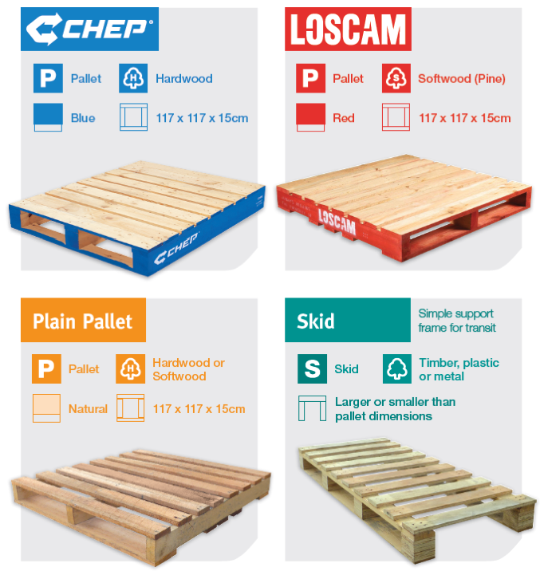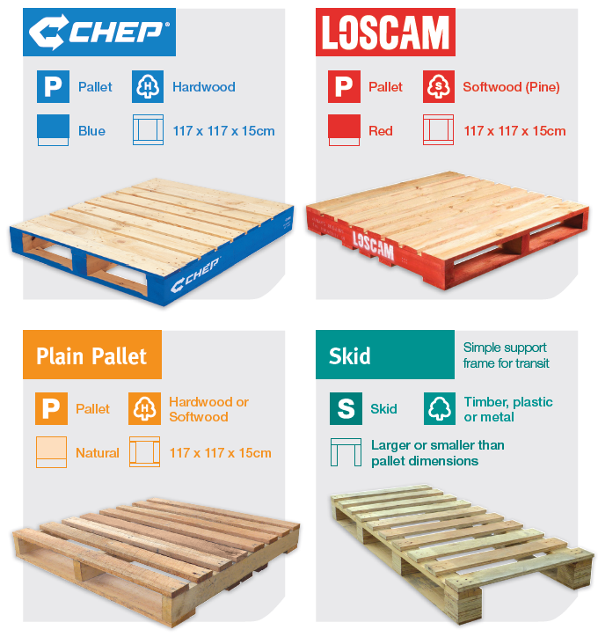

Customer declaration

AUTHORISED REPRESENTATIVE
I / we have read, understood, and agree to the Team Global Express Pooled Equipment Trading Agreement.

Name: ………………………………………………Signature: ………………………… Date: ………/………/………

TRADING REPRESENTATIVE OF:
Name: ………………………………………………Signature: ………………………… Date: ………/………/………
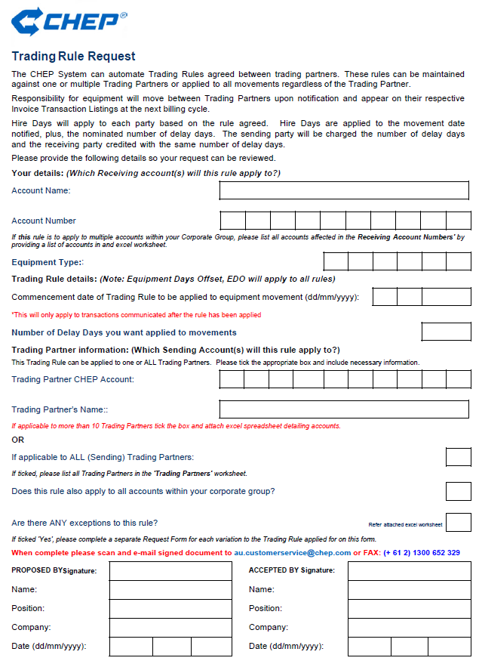



Backed by an unrivalled and seamless network, Team Global Express builds unique, innovative and tailored solutions across road, rail, air and sea; providing transport, logistics, and business solutions to customers throughout Australia and New Zealand.

For more information on how we can support you, contact us via tgexpress.com.au

